Supplemental Information

**Single-cell virology: on-chip investigation of viral infection dynamics**

|  |  |
| --- | --- |
| **Figure S1** | Comparison of the kinetics of GFP fluorescence on-chip to that off-chip |
| **Figure S2** | Mask designs |
| **Figure S3** | Experimental setup |
| **Figure S4** | Experimental data |
| **Figure S5** | Substantial between-cell variability in the kinetics of GFP fluorescence  is observed post infection |
| **Figure S6** | Wells excluded and included in data analysis |
| **Figure S7** | Models used for data analysis |
| **Figure S8** | Examples of model fitting |
| **Figure S9** | Average curves for MOI experiment |
| **Figure S10** | Growth of an attenuated PV mutant in cell culture appears identical to  WT using a one-step growth experiment |
| **Figure S11** | Impact of start time delays on virus yield in the presence of constant  intrinsic and innate antiviral defenses |
| **Table S1** | Quantifications of the GFP-PV WT and H273R viruses experiment |
| **Table S2** | Mean and standard deviation values for maximum, midpoint, slope, infection time and start point for single cell virology experiments |
| **Table S3** | Adjusted P-values of the t-tests for the MOI experiment |
| **Table S4** | Adjusted P-values of the t-tests for the cell cycle experiment |
| **Table S5** | Adjusted P-values of the t-tests for the Infection Model and  Infection and Lysis Model |
| **Table S6** | Adjusted P-values of the t-tests for the virus mutant experiment |
| **Table S7** | Adjusted P-values of the t-tests for the antiviral drug treatment |
| **Video S1** | Infections in cell culture plate |
| **Video S2** | Infections in isolated wells |
| **Video S3** | Sealed wells |
| **Supplemental Experimental Procedures** | |



**Figure S1. Comparison of the kinetics of GFP fluorescence on-chip to that off-chip.** HeLa S3 cells were infected with GFP-PV (5000 genomes/cell) and kept off-chip in the presence or absence of the replication inhibitor guanidine hydrochloride (GuHCl), or loaded onto the device (on-chip). The change in fluorescence was monitored as a function of time. The absence of GFP in the presence of GuHCl shows that replication is required to observe a GFP signal. The kinetics of GFP fluorescence post-infection is essentially the same on and off chip.

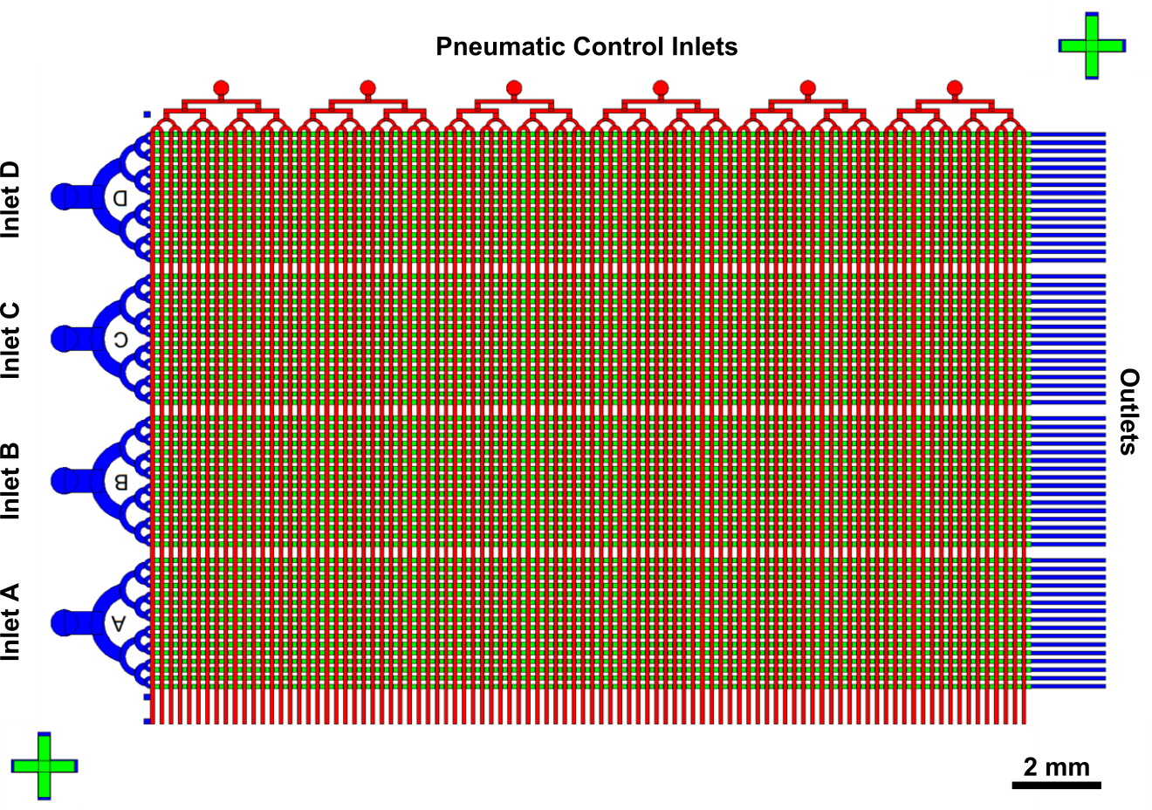

**Figure S2.** **Mask design.** The whole design consists of an array of 6,400 isolated wells. Four individual inlets were designed for injecting four different cell/virus solutions, and each inlet was connected to 1,600 wells. Six individual inlets were designed for pneumatic isolation of the 6400 wells. The green, blue and red colors indicate the masks for the well layer, flow layer and control layer, respectively.

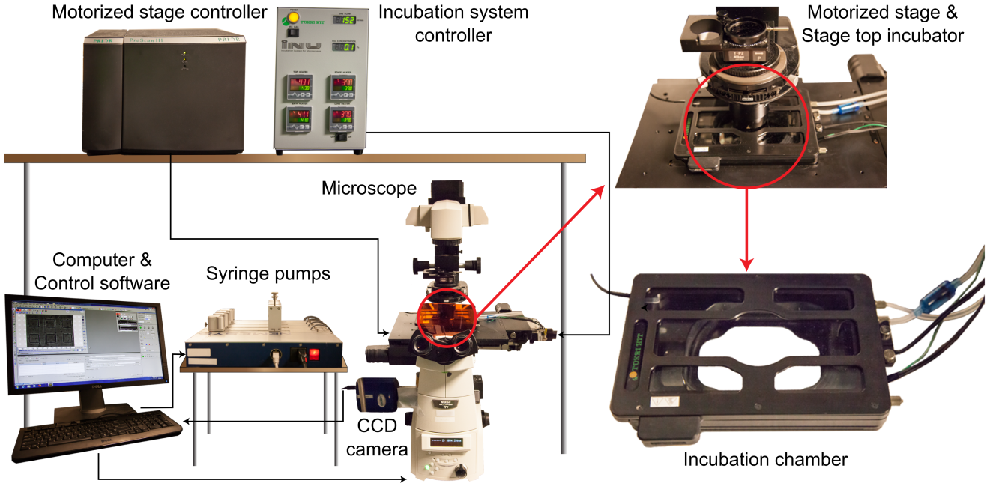

**Figure S3.** **Experimental setup.** A microscope incubation system (temperature, CO2, and humidity control) was installed on top of the motorized stage for on-chip cell culture. The CCD camera and motorized stage connected to the microscope enabled time-lapsed, multipoint, live-cell imaging. Syringe pumps were used for controlled loading of cell/virus solutions into the microfluidic device. The NIS-Elements AR software from Nikon was used for automated control of the CCD camera and motorized stage during data acquisition, while syringe pumps were controlled by the neMESYS UserInterface software.

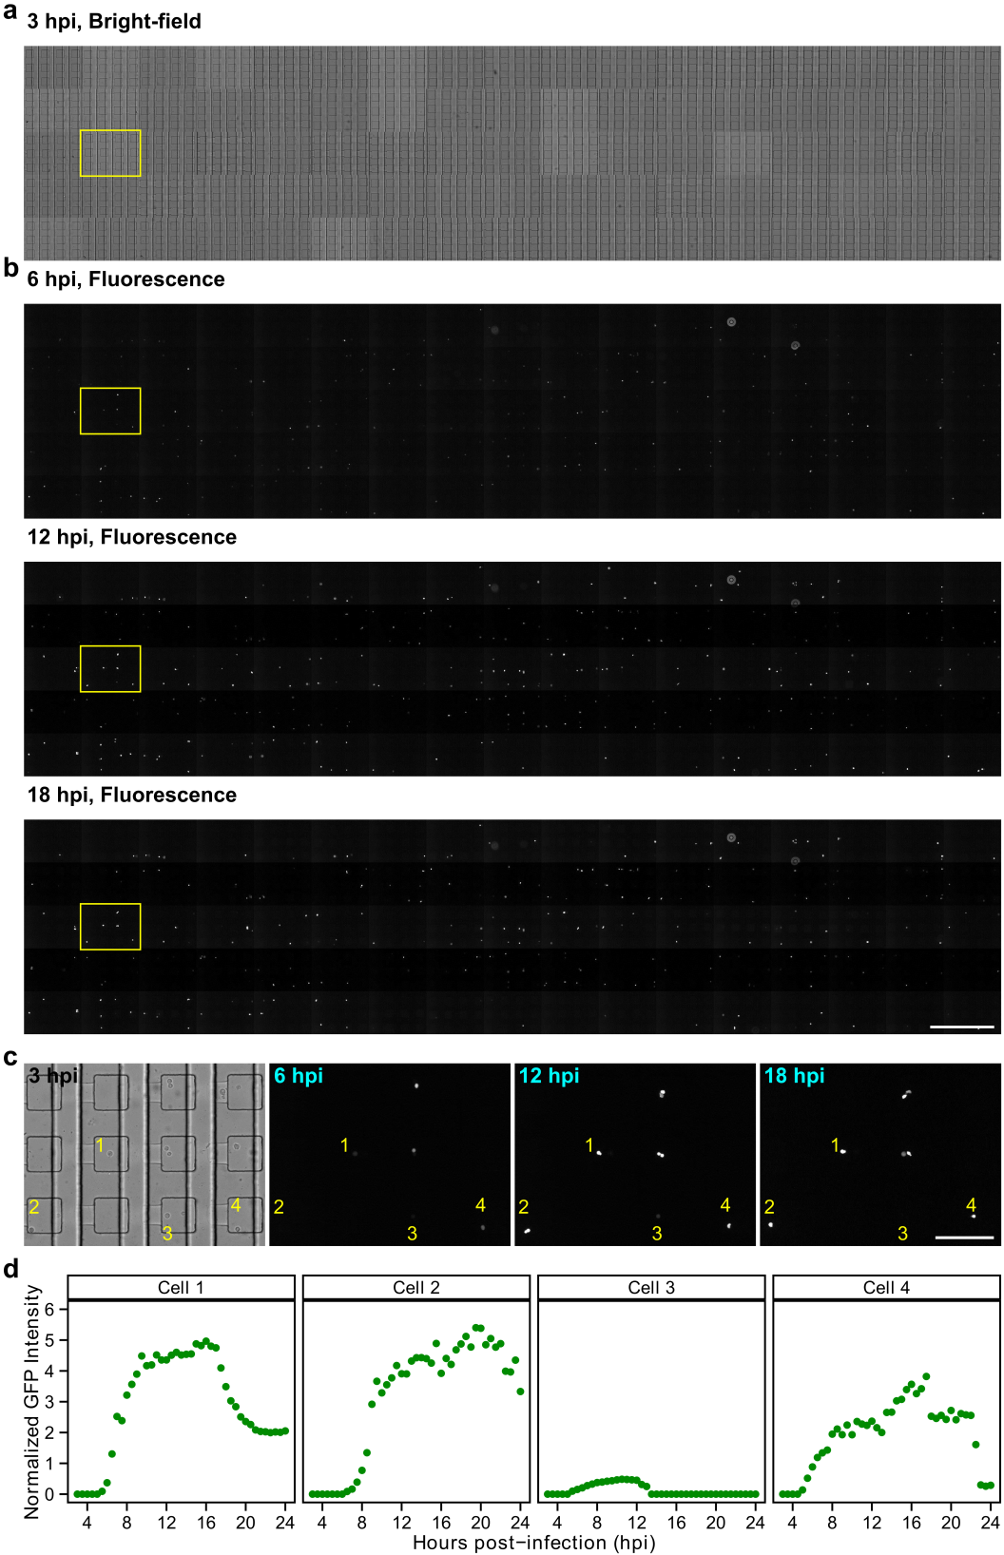

**Figure S4.** **Experimental data.** (**a**) Stitched bright-field image (3 hours post-infection (hpi)) showing wells connected to one inlet. (**b**) Three corresponding fluorescence images (6, 12 and 18 hpi) showing GFP signals of infected cells (white dots). Scale bar = 1 mm. (**c**) Enlarged images of the rectangular regions in (b). Four, single, infected cells can be identified. Scale bar = 200 µm. (**d**) Plots of the normalized GFP intensity vs. hpi for the four single infected cells in (c).

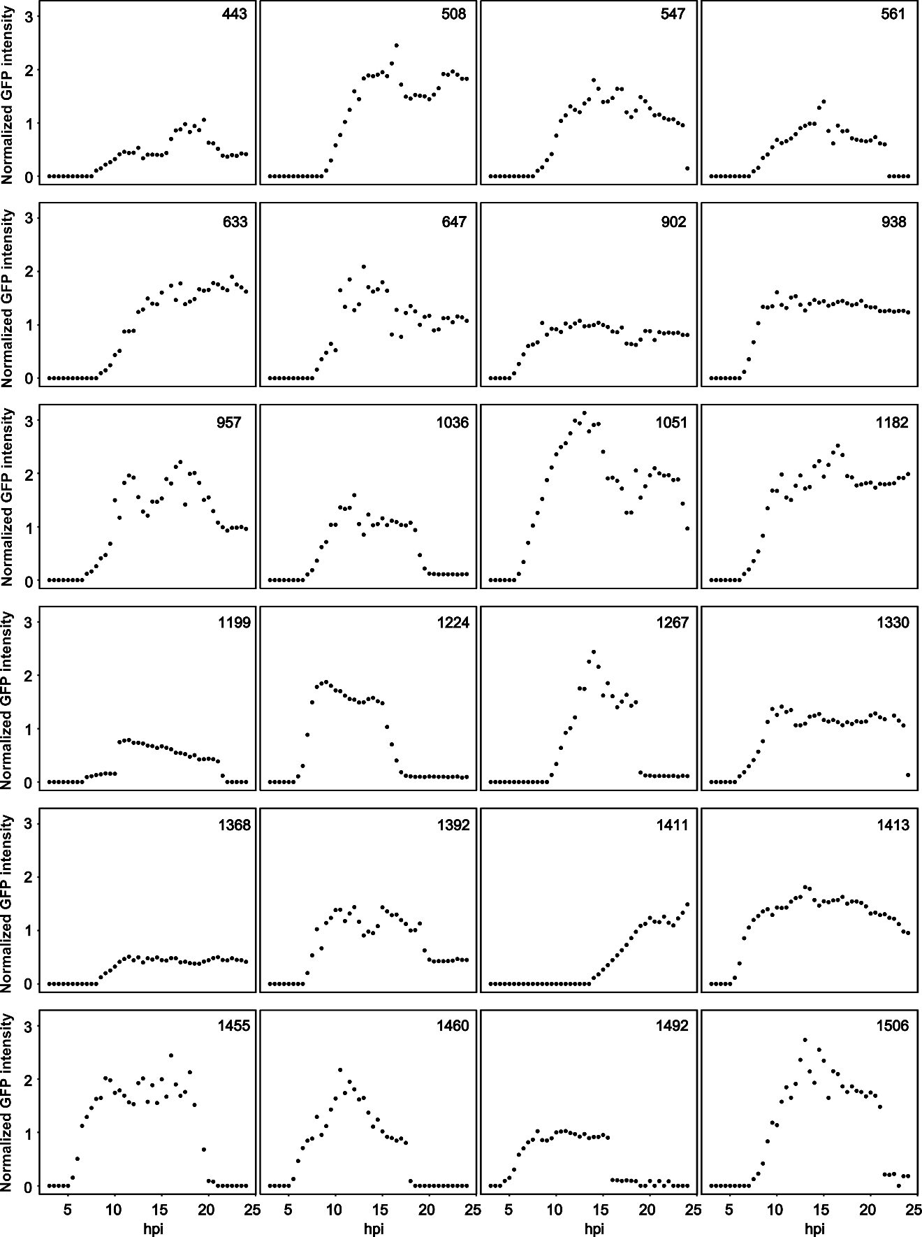

**Figure S5.** **Substantial between-cell variability in the kinetics of GFP fluorescence is observed post infection.** Randomly selected infections of WT at an MOI of 50 genomes/cell.

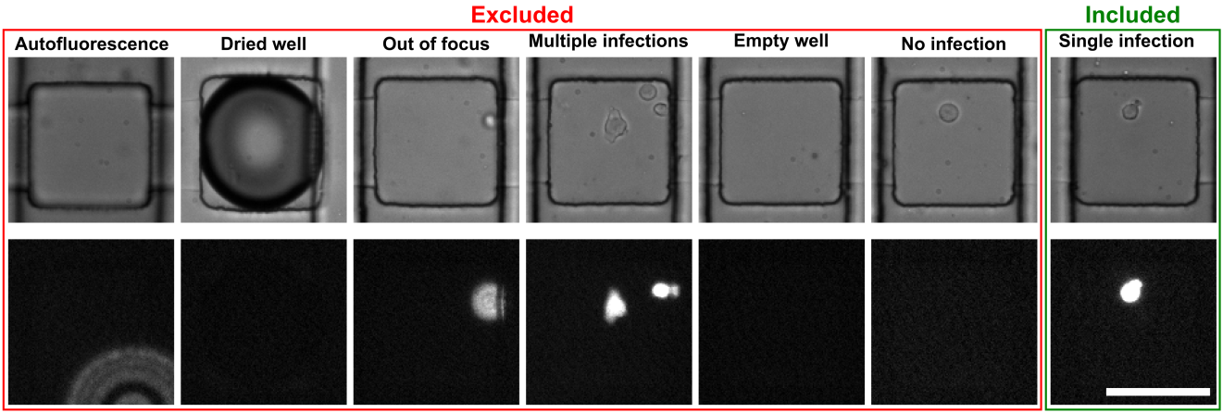

**Figure S6.** **Wells excluded or included in data analysis.** During manual examination of experimental data, we excluded wells showing auto-fluorescence, dried wells, and out-of-focus GFP signals. Wells containing multiple infected cells were excluded by the MATLAB code during image processing. Empty wells and wells with no infection were excluded by the R code during model fitting. In our final data analysis, only wells containing single infected cells were included. Scale bar = 100 µm.

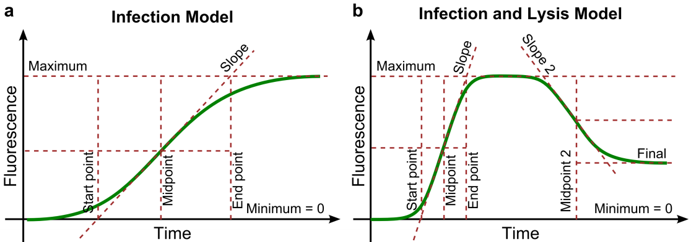

**Figure S7.** **Models used for data analysis.** (**a**) In the infection model, we define five parameters of interest. The maximum represents the greatest value of fluorescence intensity, which corresponds to the asymptotic value of the fluorescence intensity at late times. The midpoint represents the time at which the fluorescence intensity has risen to half of its maximum, and the slope is the slope of the fluorescence intensity curve at the midpoint. The start point is the time point in which a straight line representing the slope intersects the line of zero intensity, and the end point is the time point in which the same line intersects the line of maximum intensity. (**b**) In the infection and lysis model, we define the same five parameters of interest as in the infection model, plus an additional three: the final is the asymptotic fluorescence intensity at late times, which is lower than the maximum. Midpoint 2 is the time point at which the fluorescence intensity has decayed to half of the final value. Slope 2 is the slope of the fluorescence intensity curve at Midpoint 2.

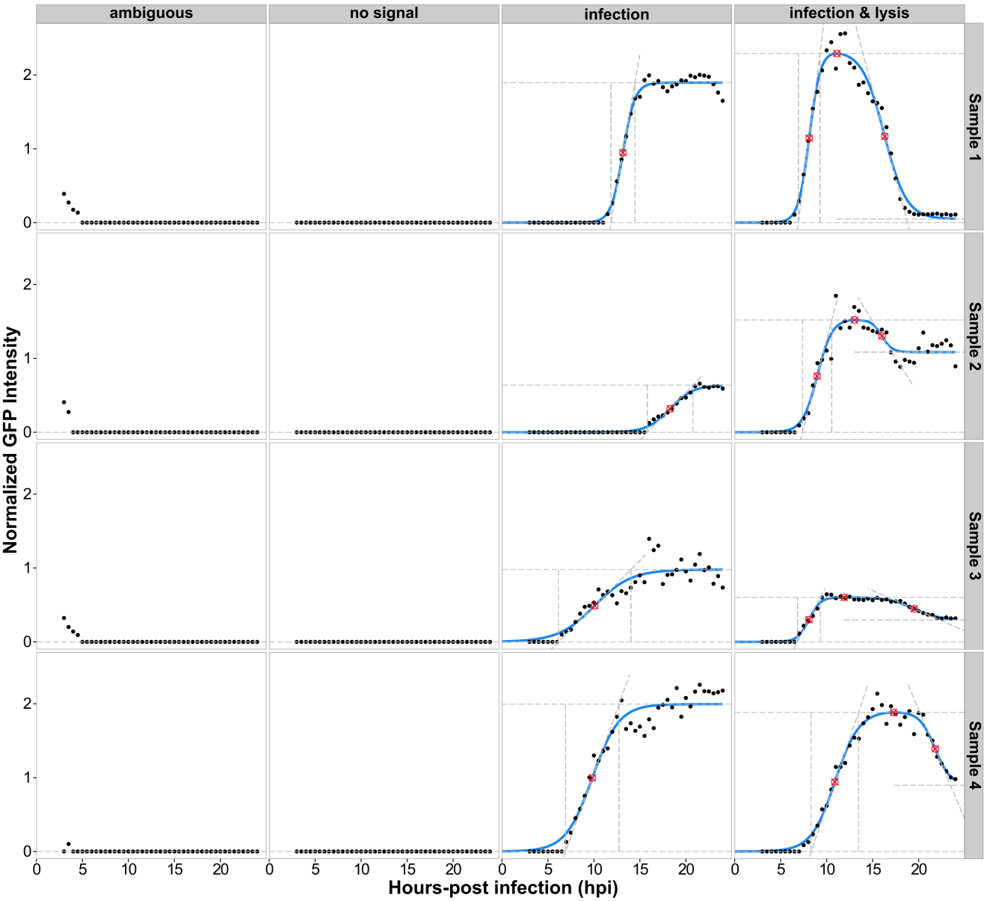

**Figure S8.** **Examples of model fitting.** Sixteen representative example time courses were automatically classified into “ambiguous,” “no signal,” “infection,” and “infection and lysis” respectively.

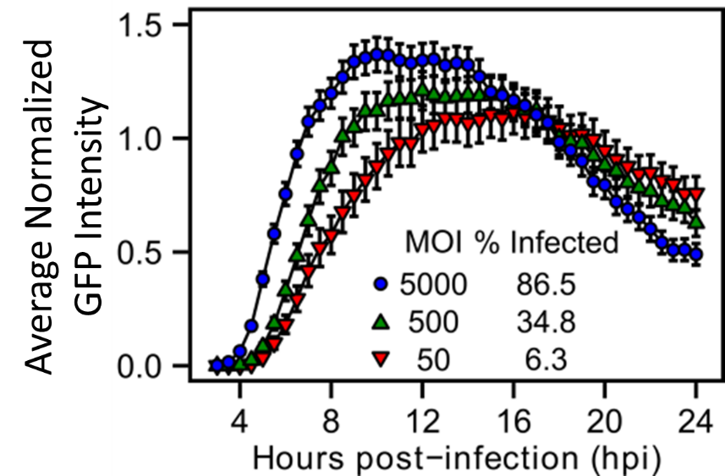**Figure S9.** **Average curves for MOI experiment.** Cells were infected with GFP-PV at an MOI of 5,000, 500 or 50 genomes per cell and then loaded onto the device. Averaged curves of viral infection dynamics on single cells from the different infections. Data are presented as means ± SEM. The percentage of infected cells for each MOI is also shown.

**Figure S10. Growth of an attenuated PV mutant in cell culture appears identical to WT using a one-step growth experiment.** One-step-growth curves of WT and H273R PV. Viral titer (pfu/ml) was plotted against hours post-infection (Korboukh et al., 2014). Data are presented as means ± SEM (n=3).

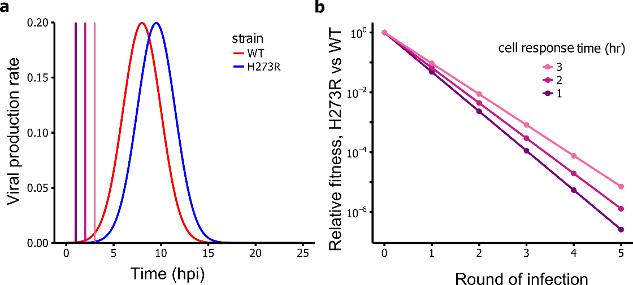

**Figure S11. Impact of start time delays on virus yield in the presence of constant intrinsic and innate antiviral defenses.** A simple simulation model highlights the dramatic effect of a short replication delay on relative viral fitness, assuming an effective intrinsic and innate immune response. (**a**) Model assumptions. We assume that the H273R mutant has a short replication delay (1.5 h) relative to WT. All other parameters are identical for mutant and WT. Both are modeled as producing offspring virus according to a Gaussian curve with maximum viral production at 8h and a standard deviation of 2 h (solid curves). After the first round of viral replication in the host tissue, cells are assumed to respond with an intrinsic/innate immune response that completely shuts off viral replication sometime after the cell is infected. We modeled the intrinsic/innate immune response as taking effect at 1, 2, or 3 hours post-infection (vertical dashed lines). (**b**) Mutant fitness relative to WT as a function of the number of rounds of infection. Because the innate immune response is turned on so early in the viral replication cycle, it dramatically amplifies the small replication delay of H273R relative to WT. After only a few rounds of infection, H273R is suppressed by several orders of magnitude relative to WT. This amplification of a small delay explains why WT and H273R cause dramatically different phenotypes in vivo.

**SI Tables**

**Table S1.** Quantifications of the GFP-PV WT and H273R viruses based on pfu or genomes.

|  |  |  |  |
| --- | --- | --- | --- |
| virus | pfu/ml | genomes/ml | genomes/pfu |
| GFP-PV WT | 4.1 ± 0.4 × 107 | 4.4 ± 0.9 × 1010 | 1.1 ± 0.3 × 103 |
| GFP-PV H273R | 1.2 ± 0.3 × 107 | 2.9 ± 0.4 × 1010 | 2.5 ± 0.7 × 103 |

**Table S2.** Mean and standard deviation values for maximum, midpoint, slope, infection time and start point for single cell virology experiments.

|  |  |  |  |  |  |  |  |  |  |  |  |  |  |
| --- | --- | --- | --- | --- | --- | --- | --- | --- | --- | --- | --- | --- | --- |
|  |  |  |  | **Maximum** | | **Midpoint** | | **Slope** | | **Infection time** | | **Start point** | |
| **Data set** | **Condition** | **Mutation** | **MOI** | **Mean** | **Sd.** | **Mean** | **Sd.** | **Mean** | **Sd.** | **Mean** | **Sd.** | **Mean** | **Sd.** |
| SCV028 | MOI 50 | WT | 50 | 1.37 | 0.9 | 10.99 | 4.91 | 0.46 | 0.45 | 4.19 | 3.03 | 8.9 | 5.07 |
| SCV029 | MOI 500 | WT | 500 | 1.43 | 0.86 | 9.18 | 4.22 | 0.63 | 0.51 | 3.05 | 2.2 | 7.66 | 4.35 |
| SCV030 | MOI 5000 | WT | 5000 | 1.58 | 0.96 | 6.83 | 2.98 | 0.9 | 0.97 | 2.33 | 1.39 | 5.67 | 3.12 |
| SCV031 | 0 µM 2'-C-meA | WT | 500 | 1.59 | 0.8 | 9.05 | 2.75 | 0.73 | 0.77 | 3.39 | 2.09 | 7.36 | 2.75 |
| SCV032 | 50 µM 2'-C-meA | WT | 500 | 1.12 | 0.62 | 8.52 | 2.39 | 0.48 | 0.38 | 3.2 | 2.18 | 6.92 | 2.28 |
| SCV035 | Control | WT | 500 | 1.78 | 0.8 | 8.22 | 2.42 | 0.82 | 0.69 | 2.97 | 1.71 | 6.74 | 2.28 |
| SCV036 | G0/G1 phase | WT | 500 | 1.74 | 0.73 | 8.57 | 2.94 | 0.72 | 0.54 | 3.12 | 1.86 | 7.01 | 2.88 |
| SCV037 | G2/M phase | WT | 500 | 1.81 | 0.9 | 8.19 | 2.41 | 0.74 | 0.55 | 2.99 | 1.4 | 6.7 | 2.31 |
| SCV038 | WT 50 | WT | 50 | 1.46 | 0.56 | 9.58 | 2.63 | 0.53 | 0.36 | 3.73 | 2.39 | 7.72 | 2.38 |
| SCV039 | WT 5000 | WT | 5000 | 1.68 | 0.7 | 7.25 | 2.2 | 0.63 | 0.39 | 3.34 | 1.64 | 5.58 | 2.05 |
| SCV040 | HR 50 | HR | 50 | 1.54 | 0.71 | 9.78 | 2.87 | 0.62 | 0.35 | 2.91 | 1.38 | 8.32 | 2.65 |
| SCV041 | HR 5000 | HR | 5000 | 1.76 | 0.64 | 7.99 | 1.84 | 0.78 | 0.52 | 2.7 | 1.19 | 6.64 | 1.74 |
| SCV096 | EGFP | WT | 2000 | 1.87 | 1.44 | 6.79 | 2.14 | 0.86 | 0.67 | 2.53 | 1.3 | 5.52 | 2.11 |
| SCV097 | mCherry | WT | 2000 | 2.52 | 1.61 | 8.65 | 2.21 | 1.13 | 0.76 | 2.55 | 1.34 | 7.37 | 2.18 |
| SCV098 | EGFP+mCherry EGFP Signal | WT | 2000 | 1.6 | 1.1 | 6.97 | 2.03 | 0.81 | 0.58 | 2.28 | 1.22 | 5.84 | 2.08 |
| SCV099 | EGFP+mCherry mCherry Signal | WT | 2000 | 1.9 | 1.3 | 7.78 | 2.01 | 0.91 | 0.65 | 2.36 | 1.12 | 6.6 | 1.98 |

The experiment notations refer to the following: SCV028-030: MOI experiment (MOI = 50, 500, 5000 for WT PV-GFP); SCV035-037: cell cycle experiment (Unsorted, G1/S, G2/M); GFP + mCherry co-infection; SCV038-041: mutant experiment (WT vs H273R PV-GFP (MOI = 50 and 5000)); SCV031-032: drug treatment experiment (0 vs 50 mM 2'-C-meA).

**Table S3.** Adjusted P-values of the t-tests for the MOI experiment.

|  |  |  |  |  |  |
| --- | --- | --- | --- | --- | --- |
| **Maximum** |  | MOI 50 | MOI 500 | MOI 5000 | Sample size |
| MOI 50 | 1 | 0.66 | 0.24 | 92 |
| MOI 500 | 0.66 | 1 | 0.24 | 127 |
| MOI 5000 | 0.24 | 0.24 | 1 | 190 |
| Sample size | 92 | 127 | 190 |  |
| **Slope** |  | MOI 50 | MOI 500 | MOI 5000 | Sample size |
| MOI 50 | 1 | 0.09 | 0 | 92 |
| MOI 500 | 0.09 | 1 | 0 | 127 |
| MOI 5000 | 0 | 0 | 1 | 190 |
| Sample size | 92 | 127 | 190 |  |
| **Midpoint** |  | MOI 50 | MOI 500 | MOI 5000 | Sample size |
| MOI 50 | 1 | 0 | 0 | 92 |
| MOI 500 | 0 | 1 | 0 | 127 |
| MOI 5000 | 0 | 0 | 1 | 190 |
| Sample size | 92 | 127 | 190 |  |
| **Start point** |  | MOI 50 | MOI 500 | MOI 5000 | Sample size |
| MOI 50 | 1 | 0.02 | 0 | 92 |
| MOI 500 | 0.02 | 1 | 0 | 127 |
| MOI 5000 | 0 | 0 | 1 | 190 |
| Sample size | 92 | 127 | 190 |  |
| **Infection time** |  | MOI 50 | MOI 500 | MOI 5000 | Sample size |
| MOI 50 | 1 | 0 | 0 | 92 |
| MOI 500 | 0 | 1 | 0 | 127 |
| MOI 5000 | 0 | 0 | 1 | 190 |
| Sample size | 92 | 127 | 190 |  |

**Table S4.** Adjusted P-values of the t-tests for the cell cycle experiment. A Benjamini–Hochberg correction was performed to control the false discovery rate introduced by multiple testing (Benjamini and Hochberg, 1995).

|  |  |  |  |  |  |
| --- | --- | --- | --- | --- | --- |
| **Maximum** |  | Control | G0/G1 phase | G2/M phase | Sample size |
| Control | 1 | 0.74 | 0.74 | 163 |
| G0/G1 phase | 0.74 | 1 | 0.74 | 264 |
| G2/M phase | 0.74 | 0.74 | 1 | 143 |
| Sample size | 163 | 264 | 143 |  |
| **Slope** |  | Control | G0/G1 phase | G2/M phase | Sample size |
| Control | 1 | 0.24 | 0.36 | 163 |
| G0/G1 phase | 0.24 | 1 | 0.71 | 264 |
| G2/M phase | 0.36 | 0.71 | 1 | 143 |
| Sample size | 163 | 264 | 143 |  |
| **Midpoint** |  | Control | G0/G1 phase | G2/M phase | Sample size |
| Control | 1 | 0.28 | 0.92 | 163 |
| G0/G1 phase | 0.28 | 1 | 0.28 | 264 |
| G2/M phase | 0.92 | 0.28 | 1 | 143 |
| Sample size | 163 | 264 | 143 |  |
| **Start point** |  | Control | G0/G1 phase | G2/M phase | Sample size |
| Control | 1 | 0.42 | 0.89 | 163 |
| G0/G1 phase | 0.42 | 1 | 0.42 | 264 |
| G2/M phase | 0.89 | 0.42 | 1 | 143 |
| Sample size | 163 | 264 | 143 |  |
| **Infection time** |  | Control | G0/G1 phase | G2/M phase | Sample size |
| Control | 1 | 0.72 | 0.9 | 163 |
| G0/G1 phase | 0.72 | 1 | 0.72 | 264 |
| G2/M phase | 0.9 | 0.72 | 1 | 143 |
| Sample size | 163 | 264 | 143 |  |

**Table S5.** Adjusted P-values of the t-tests for Infection Model and Infection and Lysis Model.

|  |  |  |  |  |
| --- | --- | --- | --- | --- |
| **Maximum** |  | infection | infection&lysis | Sample size |
| infection | 1 | 0 | 28 |
| infection&lysis | 0 | 1 | 135 |
| Sample size | 28 | 135 |  |
| **Slope** |  | infection | infection&lysis | Sample size |
| infection | 1 | 0 | 28 |
| infection&lysis | 0 | 1 | 135 |
| Sample size | 28 | 135 |  |
| **Midpoint** |  | infection | infection&lysis | Sample size |
| infection | 1 | 0 | 28 |
| infection&lysis | 0 | 1 | 135 |
| Sample size | 28 | 135 |  |
| **Start point** |  | infection | infection&lysis | Sample size |
| infection | 1 | 0 | 28 |
| infection&lysis | 0 | 1 | 135 |
| Sample size | 28 | 135 |  |
| **Infection time** |  | infection | infection&lysis | Sample size |
| infection | 1 | 0 | 28 |
| infection&lysis | 0 | 1 | 135 |
| Sample size | 28 | 135 |  |

**Table S6.** Adjusted P-values of the t-tests for the virus mutant experiment.

|  |  |  |  |  |  |  |
| --- | --- | --- | --- | --- | --- | --- |
| **Maximum** |  | HR 50 | HR 5000 | WT 50 | WT 5000 | Sample size |
| HR 50 | 1 | 0.01 | 0.46 | 0 | 87 |
| HR 5000 | 0.01 | 1 | 0.11 | 0.15 | 246 |
| WT 50 | 0.46 | 0 | 1 | 0.01 | 99 |
| WT 5000 | 0.11 | 0.15 | 0.01 | 1 | 354 |
| Sample size | 87 | 246 | 99 | 354 |  |
| **Slope** |  | HR 50 | HR 5000 | WT 50 | WT 5000 | Sample size |
| HR 50 | 1 | 0.01 | 0.21 | 0 | 87 |
| HR 5000 | 0.01 | 1 | 0.84 | 0 | 246 |
| WT 50 | 0.21 | 0 | 1 | 0.07 | 99 |
| WT 5000 | 0.84 | 0 | 0.07 | 1 | 354 |
| Sample size | 87 | 246 | 99 | 354 |  |
| **Midpoint** |  | HR 50 | HR 5000 | WT 50 | WT 5000 | Sample size |
| HR 50 | 1 | 0 | 0.56 | 0 | 87 |
| HR 5000 | 0 | 1 | 0 | 0 | 246 |
| WT 50 | 0.56 | 0 | 1 | 0 | 99 |
| WT 5000 | 0 | 0 | 0 | 1 | 354 |
| Sample size | 87 | 246 | 99 | 354 |  |
| **Start point** |  | HR 50 | HR 5000 | WT 50 | WT 5000 | Sample size |
| HR 50 | 1 | 0 | 0.05 | 0 | 87 |
| HR 5000 | 0 | 1 | 0 | 0 | 246 |
| WT 50 | 0.05 | 0 | 1 | 0 | 99 |
| WT 5000 | 0 | 0 | 0 | 1 | 354 |
| Sample size | 87 | 246 | 99 | 354 |  |
| **Infection time** |  | HR 50 | HR 5000 | WT 50 | WT 5000 | Sample size |
| HR 50 | 1 | 0.3 | 0 | 0 | 87 |
| HR 5000 | 0.3 | 1 | 0.04 | 0 | 246 |
| WT 50 | 0 | 0 | 1 | 0.04 | 99 |
| WT 5000 | 0.04 | 0 | 0.04 | 1 | 354 |
| Sample size | 87 | 246 | 99 | 354 |  |

**Table S7.** Adjusted P-values of the t-tests for the antiviral drug treatment experiment.

|  |  |  |  |  |
| --- | --- | --- | --- | --- |
| **Maximum** |  | 0 µM 2'-C-meA | 50 µM 2'-C-meA | Sample size |
| 0 µM 2'-C-meA | 1 | 0 | 154 |
| 50 µM 2'-C-meA | 0 | 1 | 173 |
| Sample size | 154 | 173 |  |
| **Slope** |  | 0 µM 2'-C-meA | 50 µM 2'-C-meA | Sample size |
| 0 µM 2'-C-meA | 1 | 0 | 154 |
| 50 µM 2'-C-meA | 0 | 1 | 173 |
| Sample size | 154 | 173 |  |
| **Midpoint** |  | 0 µM 2'-C-meA | 50 µM 2'-C-meA | Sample size |
| 0 µM 2'-C-meA | 1 | 0.06 | 154 |
| 50 µM 2'-C-meA | 0.06 | 1 | 173 |
| Sample size | 154 | 173 |  |
| **Start point** |  | 0 µM 2'-C-meA | 50 µM 2'-C-meA | Sample size |
| 0 µM 2'-C-meA | 1 | 0.12 | 154 |
| 50 µM 2'-C-meA | 0.12 | 1 | 173 |
| Sample size | 154 | 173 |  |
| **Infection time** |  | 0 µM 2'-C-meA | 50 µM 2'-C-meA | Sample size |
| 0 µM 2'-C-meA | 1 | 0.43 | 154 |
| 50 µM 2'-C-meA | 0.43 | 1 | 173 |
| Sample size | 154 | 173 |  |

**Table S8.** Adjusted P-values of the t-tests for the base experiments (all wild type with MOI 500)

|  |  |  |  |  |  |
| --- | --- | --- | --- | --- | --- |
| **Maximum** |  | WT 500 samp29 | WT 500 samp31 | WT 500 samp35 | Sample size |
| WT 500 samp29 | 1 | 0.32 | 0.01 | 127 |
| WT 500 samp31 | 0.32 | 1 | 0.06 | 161 |
| WT 500 samp35 | 0.01 | 0.06 | 1 | 169 |
| Sample size | 127 | 161 | 169 |  |
| **Slope** |  | WT 500 samp29 | WT 500 samp31 | WT 500 samp35 | Sample size |
| WT 500 samp29 | 1 | 0.37 | 0.13 | 127 |
| WT 500 samp31 | 0.37 | 1 | 0.35 | 161 |
| WT 500 samp35 | 0.13 | 0.35 | 1 | 169 |
| Sample size | 127 | 161 | 169 |  |
| **Midpoint** |  | WT 500 samp29 | WT 500 samp31 | WT 500 samp35 | Sample size |
| WT 500 samp29 | 1 | 0.84 | 0.07 | 127 |
| WT 500 samp31 | 0.84 | 1 | 0.06 | 161 |
| WT 500 samp35 | 0.07 | 0.06 | 1 | 169 |
| Sample size | 127 | 161 | 169 |  |
| **Start point** |  | WT 500 samp29 | WT 500 samp31 | WT 500 samp35 | Sample size |
| WT 500 samp29 | 1 | 0.87 | 0.12 | 127 |
| WT 500 samp31 | 0.87 | 1 | 0.12 | 161 |
| WT 500 samp35 | 0.12 | 0.12 | 1 | 169 |
| Sample size | 127 | 161 | 169 |  |
| **Infection time** |  | WT 500 samp29 | WT 500 samp31 | WT 500 samp35 | Sample size |
| WT 500 samp29 | 1 | 0.36 | 0.58 | 127 |
| WT 500 samp31 | 0.36 | 1 | 0.19 | 161 |
| WT 500 samp35 | 0.58 | 0.19 | 1 | 169 |
| Sample size | 127 | 161 | 169 |  |

.

**Legends for SI Videos:**

**Video S1. Infections in cell culture plate.** This video shows the evolution of green fluorescence over a 24-h time period in cells infected with GFP-PV and maintained in a cell-culture plate as described in **Fig. 1b**. We observed two waves of fluorescence. The second wave could easily be construed to be secondary infections.

**Video S2. Infections in isolated wells.** This video shows the evolution of green fluorescence over a 24-h time period for two cells infected with GFP-PV maintained in isolated wells as described in **Fig. 1b**. The wells shown were selected because two waves of fluorescence could be observed here as well. The second wave in this case must be a delayed, primary infection.

**Video S3. Sealed wells.** This video shows first the brightfield image of several wells, seven of which have at least one cell. We monitored evolution of green fluorescence over a 24-h time period. We observed fluorescence in two cells by 8-h post-infection with subsequent lysis. The other cells were never infected, thus demonstrating sealed wells incapable of supporting secondary infection using the microfluidics device.

**Supplemental Experimental Procedures**

**Device Fabrication**

**Control mold fabrication (height ~ 45 µm).** A 4-inch silicon wafer was dehydrated (30 minutes at 100 oC). The photoresist (SU8-2050) was poured on the center of the wafer, spun (15 seconds at 600 rpm, 40 seconds at 4,000 rpm), soft-baked (2 minutes at 65 oC, 8 minutes at 95 oC), exposed for 45 seconds under a UV light with energy density of 8 mW/cm2, and post-baked (1 minutes at 65 oC, 4 minutes at 95 oC). The whole wafer was developed in an SU8 developer primary bath for around 2 minutes, rinsed with isopropyl alcohol (IPA) and dried with compressed nitrogen. The wafer with photoresist pattern was hard-baked for 20 minutes at 150 oC.

**Fluid mold fabrication (flow layer height ~ 40 µm, wells layer height ~ 100 µm).** The fluid mold including flow layer and wells layer were fabricated with multilayer lithography.

We first made the flow layer: A 3-inch silicon wafer was dehydrated (30 minutes at 100 oC) and then treated with vaporized hexamethyldisilazane (HMDS) for 2 minutes. The photoresist (SPR220-7.0) was poured on the center of the wafer, spun on this wafer (10 seconds at 500 rpm, 90 seconds at 1,500 rpm), pre-baked (120 seconds at 115 oC), exposed for 60 seconds under a UV light with energy density of 8 mW/cm2. After 30 minutes, the whole wafer was developed in an FC-12 developer bath for around 2 minutes, rinsed with DI water and dried with compressed nitrogen. The wafer with SPR-photoresist pattern was hard-baked for 2 hours at 190 oC.

We fabricated the well array layer on top of the flow layer made earlier: The photoresist (SU8-2100) was poured on the center of the wafer with SPR-photoresist pattern, coated on this wafer (15 seconds at 600 rpm, 30 seconds at 2,000), and soft-baked (4 minutes at 65 oC, 30 minutes at 95 oC). The well array mask was precisely aligned to the inlets pattern deposited earlier, and exposed for 100 seconds under a UV light with energy density of 8 mW/cm2. After UV exposure, the wafer was post-baked (2 minutes at 65 oC, 10 minutes at 95 oC), developed in an SU8 developer primary bath for around 8 minutes, rinsed with IPA and dried with compressed nitrogen. The wafer with two overlapped photoresist patterns was hard-baked for 20 minutes at 150 oC.

**Multilayer microfluidic chip fabrication.** The control mold and fluid array mold were exposed to trimethylsilyl chloride (TMSCl) vapor for 4 minutes to facilitate the release of the PDMS layer from the mold. PDMS precursor and cross-linker (GE RTV615, ratio = 5:1) were mixed well and poured into the fluid mold to give a fluidic layer with a thickness of approximately 6 mm. Another PDMS pre-polymer mixture (GE RTV615, ratio A/B = 20:1) was spin-coated on the control mold for 1 minute at 2400 rpm. The fluid and control layers were cured at 65 oC for 40 and 20 minutes, respectively. Next, the PDMS fluid layer was released from mold, aligned and bonded to the PDMS control layer. After baking the assembly of these two layers for 12 hours at 65 oC, this two-layer assembly was pulled off, punched with holes for the fluidic inlets and attached to a pneumatic control layer. This two-layer assembly was bonded onto a glass cover slides to form a third PDMS layer. Another PDMS prepolymer mixture (GE RTV615, ratio A/B = 5:1) was spin-coated for 1 minute at 2,400 rpm. The coated glass cover slide was cured at 65 oC for 20 minutes and bonded with the two-layer assembly made earlier. The multi-layer microfluidic device was baked at 65 oC for 72 h to ensure strong bonding among different layers.In order to reduce the flow resistance, the microfluidic device was sealed into a Petri dish with 1 mL deionized (DI) water and incubated overnight in a cell culture incubator.

**Data acquisition and processing**

The grey value of a pixel in the fluorescence image was used to represent the fluorescence intensity of that pixel. For the isolation of the fluorescing cell from the background, two thresholds were designed to eliminate the background noise. In the first intensity threshold, background with a grey value smaller than the setting threshold was filtered from the raw image, which generated an image having the fluorescing cell together with small background noise spots. The second area threshold was then applied to eliminate the remaining small background noise spots, based on the fact that the area of the fluorescing cell was much larger than the background noise spots. Once the fluorescing cell was isolated, its fluorescence intensity can be found by averaging the grey values of the fluorescing region. Codes that can automatically read images and store the processed fluorescence intensity data were added to the script. As a result, the script can process a large number of time-lapse images obtained from the experiment and extract the fluorescence intensities of infected cells in an automatic, high-efficiency manner. After image processing, we manually examined the experimental data to exclude wells showing auto-fluorescence, dried wells, and wells showing out-of-focus GFP signals (**Fig. S6**). Wells containing multiple infected cells were excluded by the MATLAB script during image processing. Empty wells and wells with no infection were excluded by the R code during model fitting.

**Statistical models**

We fitted two statistical models to each intensity time course, a sigmoidal one and a double-sigmoidal one. These models are described in detail in (Caglar et al. 2017), and the fitting code is available as a stand-alone R package entitled sicegar (Single Cell Growth Analysis in R), available from the Comprehensive R Archive Network (CRAN) at: [https://CRAN.R-project.org/package=sicegar](https://cran.r-project.org/package=sicegar). Our analysis pipeline built on top of the sicegar package, as well as our raw and processed data, are available at: <https://github.com/clauswilke/Guo_etal_SCV>. For completeness, we also describe here the key concepts of the statistical models and fitting procedures.

**Sigmoidal model.** The sigmoidal model is given by

|  |  |  |
| --- | --- | --- |
|  | $$I(t)=\frac{I_{\text{max}}}{1+exp⁡[-a_{1}\left(t-t_{\text{mid}}\right)]} ,$$ | (2) |

where $I_{\text{max}}$ represents the maximum normalized GFP intensity reached during the time course, $t_{\text{mid}}$ represents the time at which the intensity has risen to half of its maximum (the midpoint of the rise phase), and $a_{1}$ represents the slope of $I(t)$ at time $t_{\text{mid}}$. This model has three independent parameters to be fit, $I_{\text{max}}$, $t_{\text{mid}}$, and $a_{1}$.

**Double-sigmoidal model.** The double-sigmoidal model is based on a simple double-sigmoidal function $f_{\text{dsig}}(t)$. This function rises from 0 to a maximum value $f_{\text{max}}$ at time $t^{*}$ and then decays back to 0. We divide this function into two parts, one to the left of the maximum $t^{*}$ (representing the infection phase) and one to the right of the maximum $t^{*}$ (representing the lysis phase). We then re-scale these two parts separately, such that the maximum value of $I\left(t\right)$ is given by $I_{\text{max}}$ and the final value of $I(t)$ for large times is given by $I_{\text{final}}>0$.

The double-sigmoidal model can be written as

|  |  |  |
| --- | --- | --- |
|  | $$I(t)=\left\{\begin{matrix}c_{1}× f_{\text{dsig}}(t) \\ c_{2} × f_{\text{dsig}}\left(t\right) + I_{\text{final}}\end{matrix}\right. \begin{matrix}\text{if} t<t^{*} \left(\text{infection phase}\right), \\ \text{if} t>t^{*} \left(\text{lysis phase}\right),\end{matrix}$$ | (3a) |

where

|  |  |  |
| --- | --- | --- |
|  | $$f_{\text{dsig}}\left(t\right)=\frac{1}{1+exp⁡[-a_{1}^{'}\left(t-t_{\text{mid}}^{'}\right)]}×\frac{1}{1+exp⁡[a_{2}^{'}\left(t-t_{\text{mid2}}^{'}\right)]} ,$$ | (3b) |
|  | $$t^{*}=\text{arg max} f_{\text{dsig}}\left(t\right),$$ | (3c) |
|  | $$f_{\text{max}}=f_{\text{dsig}}\left(t^{*}\right),$$ | (3d) |
|  | $c_{1}=I_{\text{max}} / f_{\text{max}}$, | (3e) |
|  | $c_{2}={(I}_{\text{max}}-I_{\text{final}}) / f_{\text{max}}$. | (3f) |

The parameters $a_{1}^{'}$ and $a_{2}^{'}$ determine, respectively, how quickly the function $I(t)$ rises in the infection phase and how quickly it decays in the lysis phase. These parameters determine the maximum slopes of the model in the growth and decay phases, respectively, but do not directly equal those slopes. The time point $t_{\text{mid}}^{'}$ determines (but does not exactly equal to) the time at which the intensity has risen to half of its maximum, similar to the case of the simple sigmoidal model. The time point $t_{\text{mid2}}^{'}$ (enforced to be larger than $t_{\text{mid}}^{'}$) determines the time at which the intensity has decayed halfway from its maximum to its final value. The final value of the intensity is given by $I_{\text{final}}$. The double-sigmoidal model has six independent parameters to be fit, the maximum and final intensities $I_{\text{max}}$ and $I_{\text{final}}$, the two time points $t_{\text{mid}}^{'}$ and $t_{\text{mid2}}^{'}$, and the two slope parameters $a_{1}^{'}$ and $a_{2}^{'}$.

**Fitting procedure.** Before fitting, we first check each time course for the presence of signal, considering two criteria. First, the intensity range, i.e., the absolute difference between the biggest and smallest observed intensity, must be greater than 0.1. Second, the observed maximum intensity must exceed a threshold value. Different thresholds were used throughout this work due to the use of different microscopes with sensitivity limits. The exact thresholds employed are provided in our code and data repository, <https://github.com/clauswilke/Guo_etal_SCV>. For samples that satisfy these criteria, we then fit the mathematical equations of the sigmoidal and double-sigmoidal models to the observed time courses via likelihood maximization, using the nls.lm function in the minpack.lm package of R.

To guarantee robust fitting, we run nls.lm repeatedly on the same time course, up to 500 times, and select the parameter choices that produce the overall best fit among all replicate fits for the same time course. We generally repeat the fitting procedure only until we have obtained 20 successful fits. (A successful fit is one in which the function nls.lm does not error out and returns valid parameter estimates.) In rare cases in which even 500 iterated calls of nls.lm do not result in a single successful fit, we conclude that the given model cannot accurately describe that time course.

**Extraction of biologically relevant parameters.** For the sigmoidal and the double-sigmoidal model, we define parameters of biological relevance which we extract from each fitted time course (**Fig. S7**). For the sigmoidal model, these are the start point, midpoint, end point of the infection, the slope, and the maximum intensity. Of these, the midpoint, slope, and maximum intensity are given as the fitted parameters $t_{\text{mid}}$, $a_{1}$, and $I_{\text{max}}$.

The infection start point is defined as the time point at which a line passing through the point $(t=t_{\text{mid}}, I=I(t_{\text{mid}}))$ with slope $a_{1}$ intersects with the $I=0$ line. The infection end point is defined as the time point at which that same line intersects with the $I=I_{\text{max}}$ line.

For the double-sigmoidal model, we define three additional parameters: Midpoint 2 (the midpoint of the decline during the lysis phase), Slope 2 (the slope during that decline), and the final intensity $I_{\text{final}}$. Only two relevant biological quantities in the double-sigmoidal model are obtained directly as model-fit parameters, the maximum and final intensities $I_{\text{max}}$ and $I_{\text{final}}$. The exact time points $t_{\text{mid}}$ and $t_{\text{mid2}}$ and the exact slopes $a_{1}$ and $a_{2}$ are not given by the fitted parameters $t_{\text{mid}}^{'}$, $t_{\text{mid2}}^{'}$, $a_{1}^{'}$, and $a_{2}^{'}$, and instead need to be calculated numerically. Thus, we numerically calculate the time $t_{\text{mid}}$ at which $I$ first reaches $I_{\text{max}}/2$ as well as the time $t_{\text{mid2}}$ at which $I$ first declines to ${(I}_{\text{max}}{+I}_{\text{final}})/2$ once it has started to decline from its maximum $I_{\text{max}}$. We then calculate $a_{1}$ and $a_{2}$ as the slopes of $I(t)$ at times $t_{\text{mid}}$ and $t_{\text{mid2}}$, respectively.

**Classification of time courses.** We classify all time courses into four categories: “no signal,” “infection,” “infection & lysis,” and “ambiguous” (**Fig. S8**). The category of “no signal” corresponds to cases where no GFP signal is detected, whatever the reason. (Potential reasons for no signal include failed infections, dead cells, or empty wells.) The category of “infection” corresponds to cases where a clear GFP signal is detected, and the GFP intensity does not decay towards the end of the time course. (The GFP intensity rises and then levels off.) The category of “infection & lysis” corresponds to cases where a clear GFP signal is detected, the intensity rises, levels off, and then decays again. In those cases, the decay of the GFP intensity at late times is attributed to cell lysis. Finally, time courses that cannot clearly be classified into any of these three categories are classified as “ambiguous”.

We perform this classification procedure by carrying out the following three-step algorithm. The algorithm systematically reduces the set of possible outcomes and the last remaining possible outcome becomes the decision.

The first step determines whether the intensity time course contains signal. This step is explained in subsection “Fitting procedure” above.

In the second step, the algorithm checks whether either the sigmoidal or the double-sigmoidal model fit the data in principle. For this, the algorithm first checks if we can find a fit for either the sigmoidal or the double-sigmoidal models. If not, the time course cannot be labeled as that model. Then we check the AIC (Akaike Information Criterion) values of the successful model fits. If the time course does not yield an AIC score < -10 for either the “sigmoidal” or “double-sigmoidal” models, the time-course cannot be classified as that model. Then we check the start point and start intensity of both models. The start point value must be positive, and the start intensity value must be greater than 0.05; otherwise, the time course cannot be labeled as the corresponding model. Then we check the ratios of the maximum to final intensity. For the sigmoidal model, the ratio of the model’s intensity prediction at the last observation time to the model’s maximum intensity prediction must be greater than 0.85; otherwise, the time course cannot be labeled as "sigmoidal". For the double-sigmoidal model, the ratio of the model’s intensity prediction at the last observation time to the model’s maximum intensity prediction must be smaller than 0.75; otherwise, the time course cannot be labeled as "double-sigmoidal". If at this point we still have at least one of the two options "sigmoidal" or "double-sigmoidal", then the data cannot be labeled with "ambiguous".

In the last step, the algorithm checks whether the data should be labeled as "sigmoidal" or "double-sigmoidal". If at this point we still have both options, then the choice will be made based on the AIC scores of those models. Smaller AIC score represents the decision.

**Sample preparation**

**Cell culture.** HeLa S3 cells were obtained from American Type Culture Collection (ATCC) and cultured at 37°C in DMEM/F12 medium (Cat# 11320, Life Technologies, USA) supplemented with 10% fetal bovine serum (Cat# S11050H, Atlanta Biologicals, USA), 100 U/ml penicillin and 100 μg/ml streptomycin (Cat# 30-002-CI, Corning, USA). For suspension cultures, HeLa S3 cells were grown in 125-ml flasks (Cat# 355117, Becton Dickinson, USA) shaken at 80 rpm (Mini Shaker 15, VWR, USA).

**Virus transfection, purification, and quantification.** Enhanced green fluorescent protein and mCherry-modified poliovirus type 1 Mahoney (GFP-PV, mCherry-PV) wild-type (WT) and H273R mutant were used throughout this study.

To make the virus, pMo-EGFP-WT or pMo-EGFP-H273R plasmid was first linearized with *Apa*I and purified (QIAEX II Gel Extraction Kit, Qiagen, Netherlands) by following the manufacturer’s protocol. Viral RNA was then transcribed from the linearized plasmid DNA in a 20-μl reaction mixture containing 350 mM HEPES pH 7.5, 32 mM magnesium acetate, 40 mM dithiothreitol (DTT), 2 mM spermidine, 28 mM nucleoside triphosphates (NTPs), 0.025 µg/µl linearized DNA, and 0.025 µg/µl T7 RNA polymerase. The mixture was incubated at 37°C for 5.5 hours to complete the reaction. Magnesium pyrophosphate generated during the reaction was removed by centrifugation for 2 minutes. RNA quality was checked by gel electrophoresis and RNA concentration was measured by scanning the gel in fluorescence mode (Typhoon 8600 scanner, Promega, USA). HeLa cells were transfected with 5 µg of viral RNA by electroporation, plated onto HeLa cell monolayers, and cultured at 37 °C. Upon cytopathic effect (CPE), virus was harvested by three repeated freeze-thaw cycles, centrifugation at 3000 rpm for 5 minutes to remove cell debris, and adding nonidet P-40 (NP-40) to 0.5%.

To purify the virus, the supernatant was mixed with 1 volume of 20% PEG-8000/1 M NaCl solution, incubated overnight at 4°C, and centrifuged at 8000 × g for 10 minutes at 4°C. After carefully washing the pellet with PBS, virus was resuspended in 30 ml of PBS, filtered (Centricon® Plus-70, EMD Millipore, USA) by following the manufacturer’s protocol, and resuspended in 1.5 ml of PBS to remove residual PEG.

To quantify the virus, plaque-forming units (pfu)/ml and genome copies/ml were determined through plaque assay and real-time (RT) quantitative polymerase chain reaction (qPCR), respectively. For plaque assay, virus was serially diluted in PBS, placed on HeLa cell monolayers in a 6-well plate, and incubated at room temperature (RT) for 15 to 30 minutes to infect the cells. After infection, PBS was removed and replaced with culture medium containing 1% agarose. After incubation at 37°C for 2 to 3 days, the agarose overlay was removed and cells were stained with crystal violet. Plaques were counted to determine virus titer in terms of pfu/ml. For quantification of viral genomes, viral RNA was extracted from virus samples (QIAamp Viral RNA Mini Kit, Qiagen, Netherlands) by following the manufacturer’s protocol and sent to the Genomics Core Facility of the Pennsylvania State University for RT-qPCR. Briefly, DNAse-treated RNA was reverse-transcribed (High-Capacity cDNA Reverse Transcription kit, Applied Biosystems, USA) by following the manufacturer’s protocol to make the cDNA. Quantification by RT-qPCR was conducted in a RT-PCR machine (7300 Real Time PCR System, Applied Biosystems, USA) by adding 10 or 20 ng of cDNA in a reaction with 2× universal PCR master mix (TaqMan®, Applied Biosystems, USA) in a 20-μl volume. Primers used were 5′-ACCCCTGGTAGCAATCAATATCTTAC-3′ (forward) and 5′-TTCTTTACTTCACCGGGTATGTCA-3′ (reverse), and probe used was 5′-[6-Fam] TGTGCGCTGCCTGAATTTGATGTGA-3′. A standard curve was generated using *in vitro* transcribed viral RNA.

**Drug treatment**. For the drug-treatment experiment, 2'-C-methyladenosine (2'-C-meA), a chain-terminating nucleotide analogue, was used to inhibit the replication of viral genome. 1.5 mM 2'-C-meA in dimethyl sulfoxide (DMSO) stock solution was first diluted in culture medium to desired concentration. HeLa cells were suspended in culture medium containing drug, incubated at 37 °C for 1 hour, and centrifuged at 800 rpm for 5 minutes to remove the drug. After pre-treatment, cells were mixed with virus in PBS and incubated at RT with constant shaking for 30 minutes to allow infection. After infection, cells were centrifuged at 800 rpm for 5 minutes to remove PBS, re-suspended in culture medium containing the same concentration of drug, and loaded on chip. DMSO diluted in culture medium was used as a control.

**Cell cycle.** For the cell-cycle experiment, HeLa cells were first labelled with a cell membrane-permeant, DNA-binding dye (Vybrant® DyeCycle™ Ruby stain, Life Technologies, USA) by following the manufacturer’s protocol. After labelling, cells were sorted into G0/G1 and G2/M groups using a fluorescence-activated cell sorter (FACS) (MoFlo® Astrios™, Beckman Coulter, USA). Sorted cells were then infected with virus and loaded on chip for single-cell analysis. HeLa cells which were run through the FACS and collected without sorting were used as an unsorted control.

**Supplemental References**

Benjamini, Y., and Hochberg, Y. (1995). Controlling the False Discovery Rate: A Practical and Powerful Approach to Multiple Testing. Journal of the Royal Statistical Society Series B (Methodological) *57*, 289 - 300.

Caglar M.U.​, Teufel A.I., Wilke C.O. (2017). Sicegar: R package for sigmoidal and double-sigmoidal curve fitting. PeerJ Preprints 5:e3116v1.

Korboukh, V.K., Lee, C.A., Acevedo, A., Vignuzzi, M., Xiao, Y., Arnold, J.J., Hemperly, S., Graci, J.D., August, A., Andino, R.*, et al.* (2014). RNA virus population diversity, an optimum for maximal fitness and virulence. The Journal of biological chemistry *289*, 29531-29544.